Web Development Lesson Plan

|  |  |  |
| --- | --- | --- |
| Session: 2 | Topic: Displaying content | Day: 2 |

|  |
| --- |
| Lesson Objective:  This exercise will...   * Instruct students how to display static content on web pages.   The purpose of this lesson is also that   * Students practice using Django tags within HTML pages. |
| Materials Needed:   * VS Code * Web browser |
| Agenda:   1. HTML Images (10 minutes) 2. HTML Videos (10 minutes) 3. Templates static folder (10 minutes) 4. Linking from other websites (5 minutes) |
| Procedure:  Student can do this fully independently by reading the instructions, or someone can read the instructions to make sure the task is understood before doing the activity. The reflection part can be done with guided instructions, or in pairs with other students if available to compare notes. |
| Assessment/Check for learning:   * Students can identify concrete things that they missed in their observation (note that this is not a bad thing, the purpose of this lesson is to realize that intentionally looking for information comes with the ‘penalty’ of reduced attention to other things. |

What if:

* Student has already shown proficiency in that skill?
  + Pick a movie or episode in which a lot of things are happening, so that there are more things for the student to keep track of.
* Student is having a hard day and needs special accommodations?
  + Pick a movie or episode in which only a few things are happening, so that there are less things for the student to keep track of.
  + Instead of writing, the student can also take spoken notes with an audio recorder. This will be a bit trickier in the second part but audio in the movie can be supported with subtitles.

NOTES:

* Duration is approximately 50 minutes; can be adjusted by shortening the duration of the film clip. Less than 10 minutes is not recommended unless really necessary.

**Instructions**

**HTML images (10 minutes)**

Step 1:

HTML is powerful because it allows for various inputs. One useful input is the image tag. HTML allows you to display images from other pages or display images from your server.

Step 2:

Go to the following link and try a few examples:

<https://www.w3schools.com/html/html_images.asp>

**HTML videos (10 minutes)**

Step 1:

It is also possible to display videos on HTML pages. Similar to images, it is possible to display videos from other websites or to display videos from your server.

Step 2:

Follow the link and try a few examples:

<https://www.w3schools.com/html/html5_video.asp>

**Template static folders (10 minutes)**

Step 1:

We will be displaying images from our server and from other websites. We will first cover how to display images from our server.

Step 2:

We will start be creating a new folder inside the app folder. Right click on the “my_web” folder and click on “New Folder”. Name the folder “**static”**

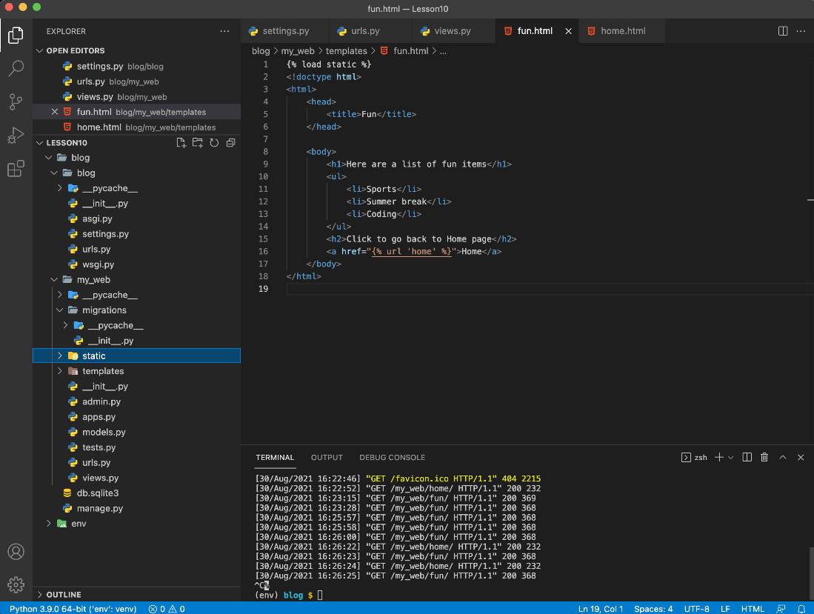

Step 3:

Now right click on “static” folder and create a new folder called “**images”**

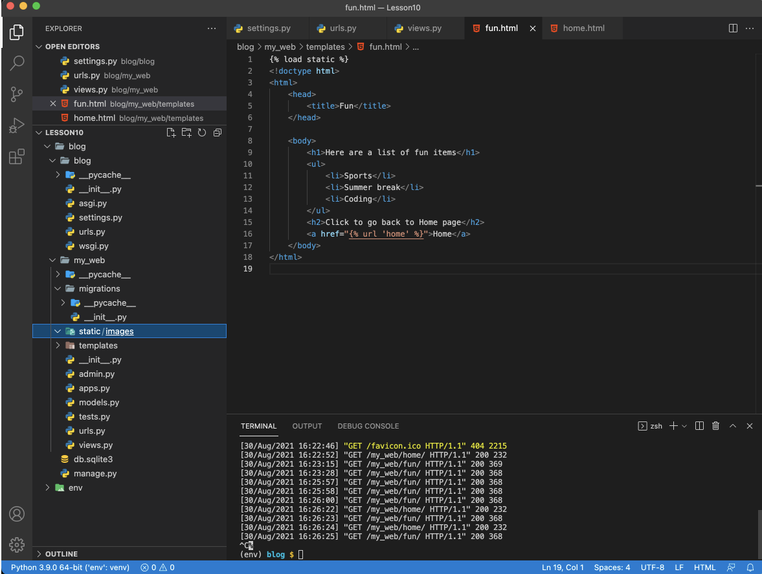

Step 4:

Download the following images and drag them into the “images” folder.

* <https://upload.wikimedia.org/wikipedia/commons/4/4d/Cat_November_2010-1a.jpg>
* <https://upload.wikimedia.org/wikipedia/commons/thumb/f/f6/11.10.2015_Samoyed_%28cropped%29.jpg/1200px-11.10.2015_Samoyed_%28cropped%29.jpg>

Step 5:

Rename the cat picture to “cat.jpeg”

Step 6:

Rename the dog picture to “dog.jpg”

Step 7:

Your folder should look like this:

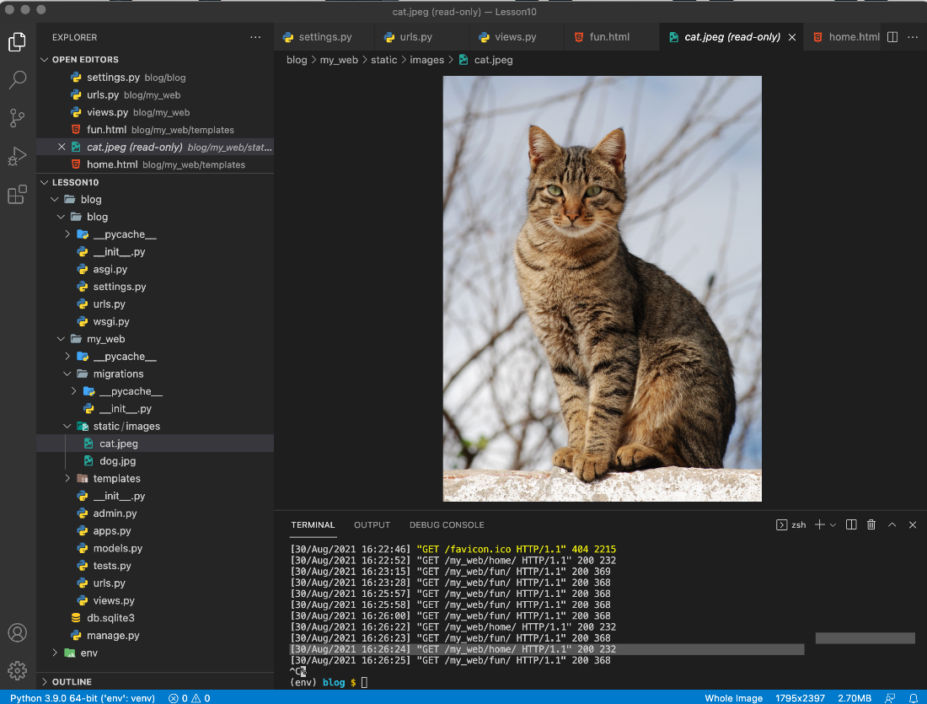

Step 12:

Now open the “home.html” file.

Step 13:

We will add our images by adding the following lines of code after line 11.

<h2>Look at these images!</h2>  
<img src="{% static 'images/cat.jpeg' %}" width="50%">  
<img src="{% static 'images/dog.jpg' %}" width="50%">

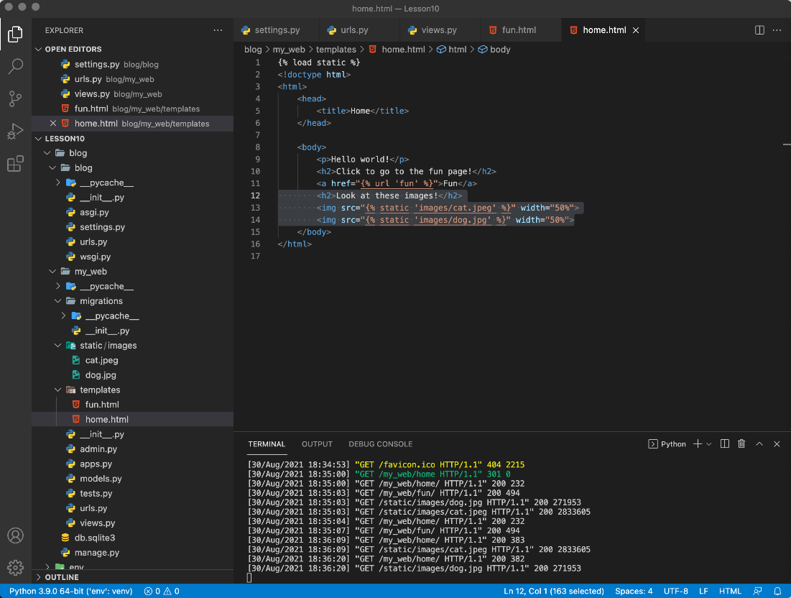

Step 14:

Run your app to confirm that your images are displaying. You should see the following.

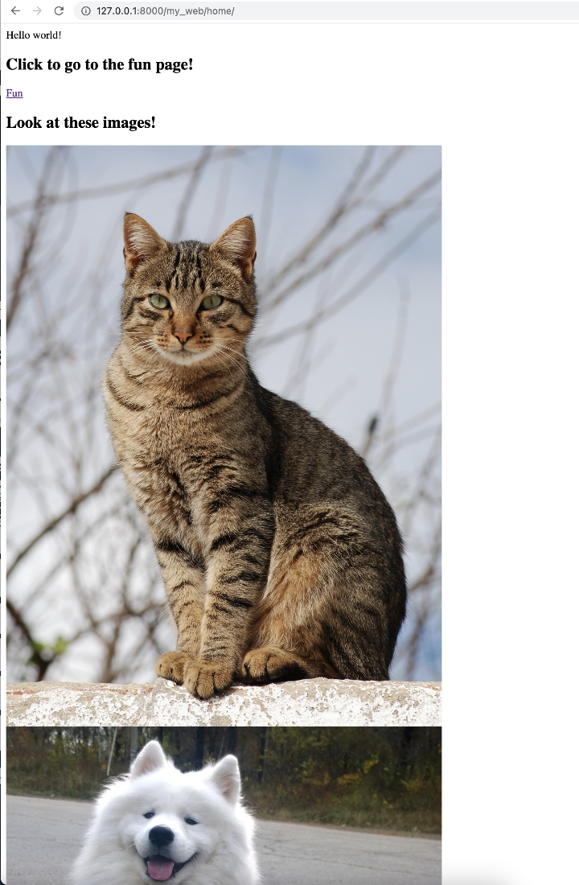

**Linking from other websites (5 minutes)**

Step 1:

Open the “fun.html” file.

Step 2:

Use the following links to create <img> tags inside of “fun.html”. Add the <img> tags after line 16.

* <https://upload.wikimedia.org/wikipedia/commons/thumb/8/89/Octopus-yacht.jpg/300px-Octopus-yacht.jpg>
* <https://upload.wikimedia.org/wikipedia/commons/5/5d/401_Gridlock.jpg>

The code should look like this:

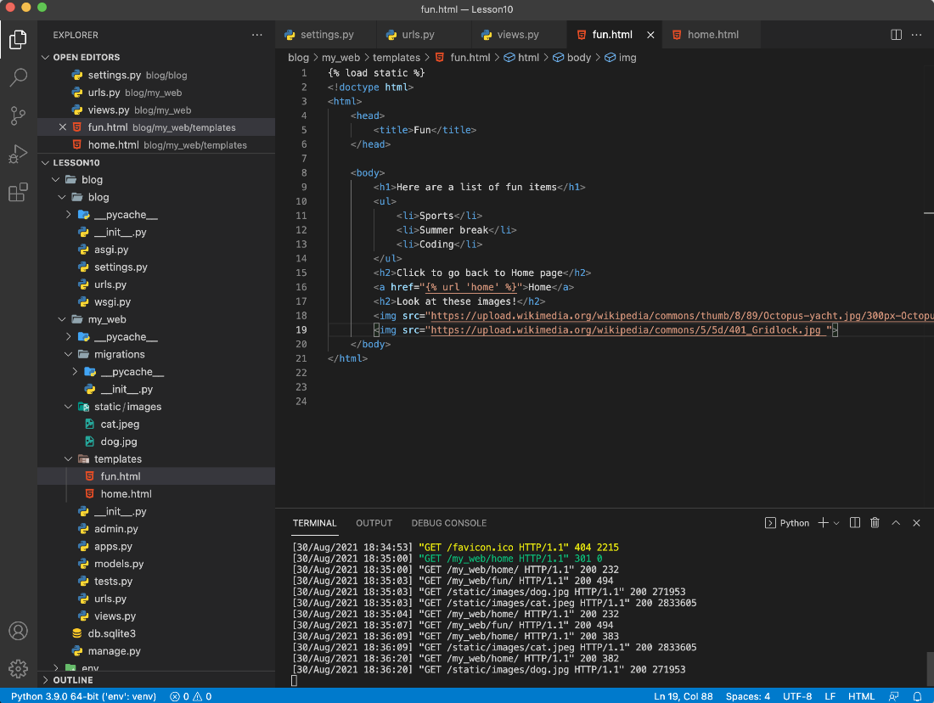

Your “fun.html” page should look like this:

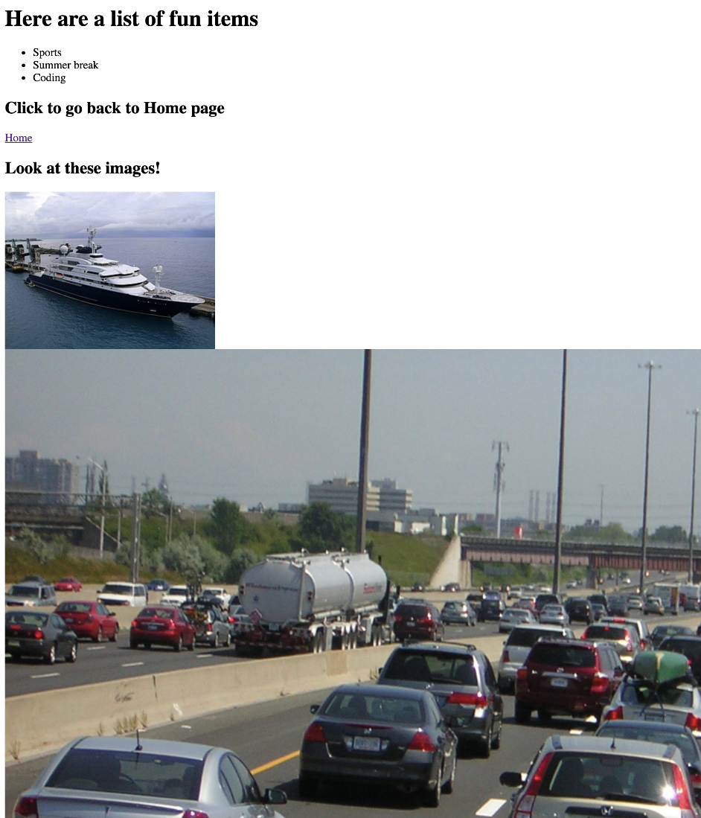

In the following lesson you will be required to create your own website.